Отчет по программированию

студента группы КТ-31-24

Киселева М.А.

Вариант 14

Лабораторная работа 8.4. Массивы. Обход матрицы

1. Условие задачи

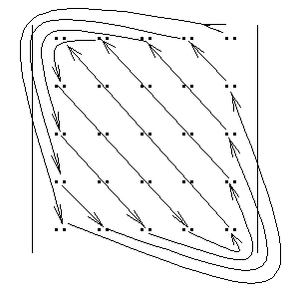

1. Блок-схема

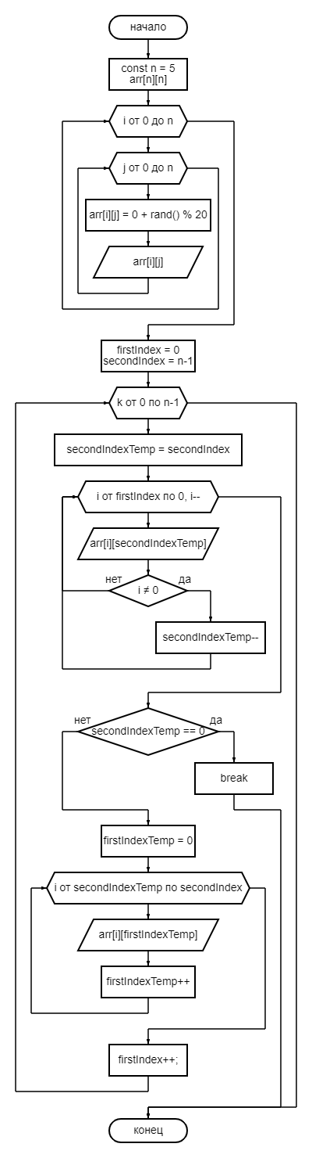

1. Программа

#include <iostream>

using namespace std;

int main() {

setlocale(LC_ALL, "Russian");

srand(time(0));

const int n = 6;

int arr[n][n];

cout << "Матрица:" << endl;

for (int i = 0; i < n; i++) {

for (int j = 0; j < n; j++) {

arr[i][j] = 0 + rand() % 20;

cout.width(3);

cout.precision(3);

cout << fixed << arr[i][j] << " ";

}

cout << endl;

}

cout << "Обход:" << endl;

int firstIndex = 0;

int secondIndex = n-1;

for (int k = 0; k <= n-1; k++) {

int secondIndexTemp = secondIndex;

for (int i = firstIndex; i >= 0; i--) {

//cout << i << " " << secondIndexTemp << endl;

cout << arr[i][secondIndexTemp] << " ";

if (i != 0) {

secondIndexTemp--;

}

}

if (secondIndexTemp == 0) {

break;

}

//cout << endl;

int firstIndexTemp = 0;

for (int i = secondIndexTemp; i <= secondIndex; i++) {

//cout << i << " " << firstIndexTemp << endl;

cout << arr[i][firstIndexTemp] << " ";

firstIndexTemp++;

}

firstIndex++;

//cout << "-----------" << endl;

}

return 0;

}

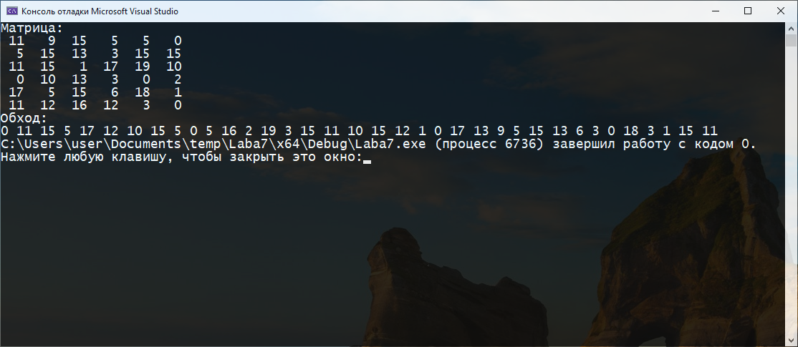arr[0][4]

arr[4][0]

arr[1][4]

arr[0][3]

arr[3][0]

arr[4][1]

arr[2][4]

arr[1][3]

arr[0][2]

arr[2][0]

arr[3][1]

arr[4][2]

……..

arr[4][4]

arr[3][3]

arr[2][2]

arr[1][1]

arr[0][0]